Computer networks 503442-3

Assignments:network security

Question 1: Complete the following sentences

- Confidentiality means that only sender, intended receiver should

“understand” message contents

- Authentication means that sender, receiver want to confirm identity of each other

- Message integrity means that sender, receiver want to ensure message not altered (in transit, or afterwards) without detection

- Access and availability means that services must be accessible and available to users

- Firewall isolates organization’s internal net from larger Internet, allowing some packets to pass, blocking others

- Stateful packet filter: track status of every TCP connection

- Deep packet inspection look at packet contents (e.g., check character strings in packet against database of known virus, attack strings)

Question 2: answer the following questions

- What can a “bad guy” do?
Ans:
- Eavesdrop
- Impersonation
- Hijacking
- Denial of service (DOS)

- Briefly explain with the aid of drawing the principles of cryptography.
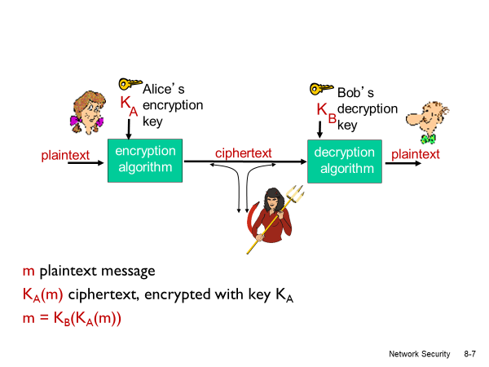

- What is the main difference between symmetric key cryptography and public key cryptography?
Ans:
Symmetric key cryptography | Public key cryptography

Main Difference:
Requires both (sender , receiver ) to know the shared secret key. | 1- sender , receiver do not share the secret key.
Additional Differences:
 | 2- public encryption key known to all.
 | 3- private decryption key known only to receiver.

- Briefly explain with the aid of drawing the principles of Digital signatures using public key cryptography
K
B

- Bob’s private
key

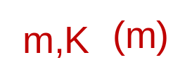

Bob’s message, m

Dear Alice
Oh, how I have missed you. I think of you all the time! …(blah blah blah)
Bob

Bob’s message, m, signed (encrypted) with his private key
Public key
encryption
algorithm

- What are the goals of Message digests?
Ans:
- Fixed-length
- Easy to compute digital fingerprint
- Apply hash function H to m
- Get fixed size message digest H(m).

- Briefly explain with the aid of drawing the principles of Digital signatures using public key cryptography and Message digests.
Ans:
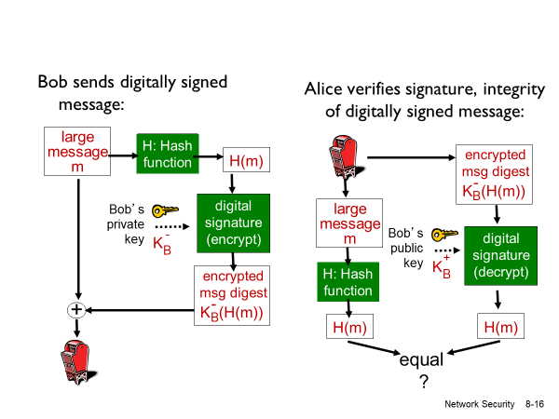

- What are the original goals of Secure Sockets Layer )SSL(?
Ans:
- Web – e – commerce transactions
- Web-server authentication
- Optional client authentication
- Encryption (especially credit card numbers)

- Describe with the aid of drawing the principles of Virtual Private Networks (VPNs)
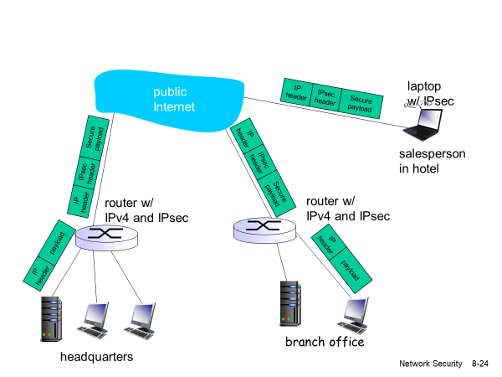

- What are the objectives of Firewalls?
Ans:
- Prevents denial of service attacks.
- Prevents illegal modifications/access of internal data.
- Allow only authorized access to inside network.

- What is the basis of the packet forwarding/dropping in stateless packet filtering in firewalls?
- Source IP address , destination IP address.
- TCP/UDP source and destination port numbers.
- ICMP message type.
- TCP SYN and ACK bits.

- Briefly explain the Stateful packet filtering in firewalls
Ans:
stateful packet filter: track status of every TCP connection.

track connection setup (SYN), teardown (FIN): determine whether incoming, outgoing packets “makes sense”.

timeout inactive connections at firewall: no longer admit packets

- What are the functions of intrusion detection system (IDS)?
Ans:

Deep packet inspection
- Examine correlation by using:

1- port scanning
2- network mapping
3- DOS attack

Best Wishes

Prof. Mohammed Abd-Elnaby.

